Infrastructure creation using Terraform
VPC and Subnet
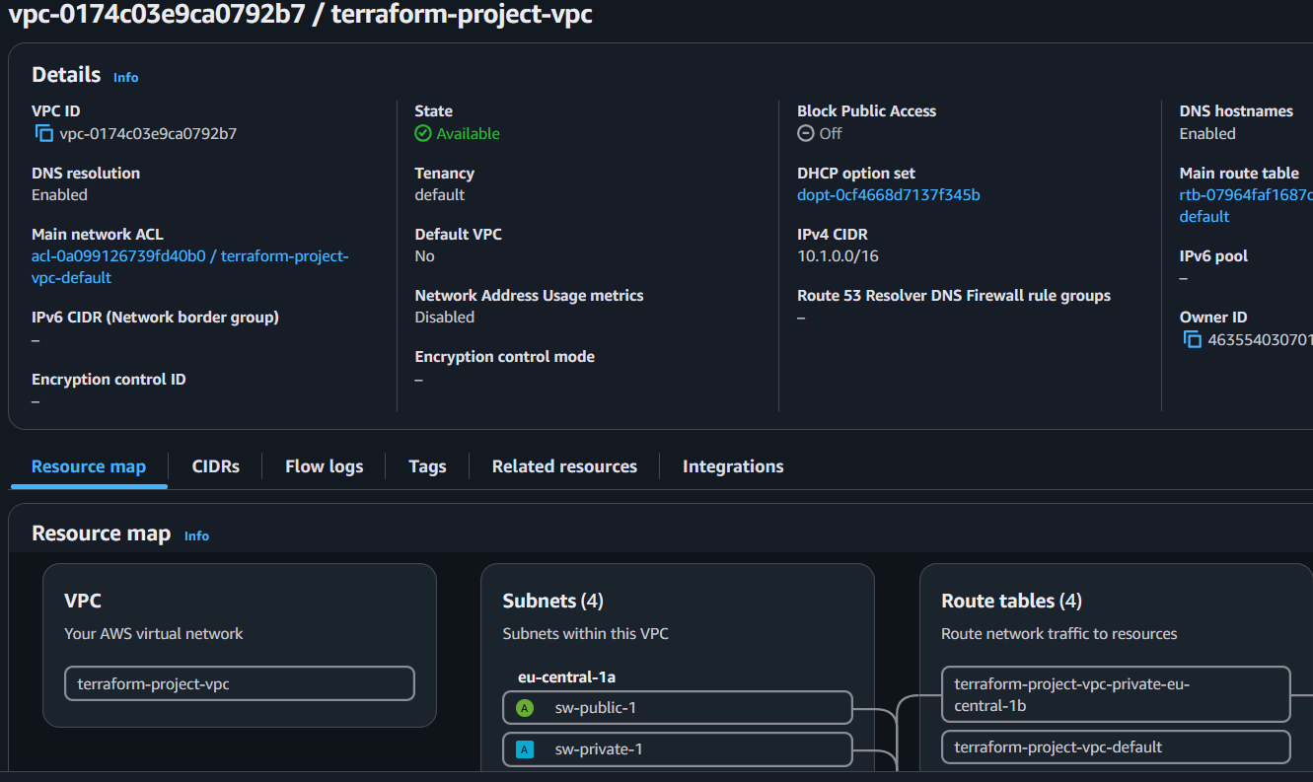
Subnet
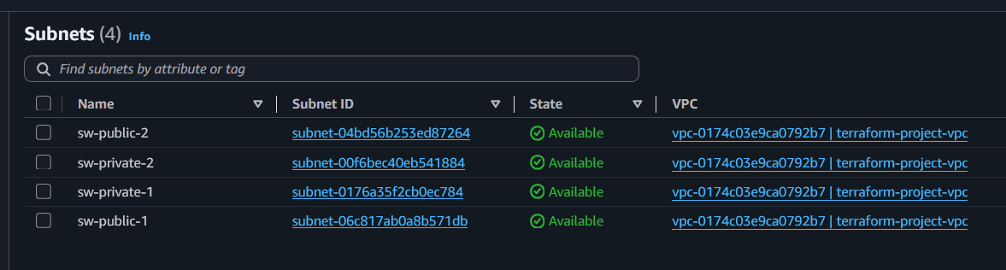
Route Tables
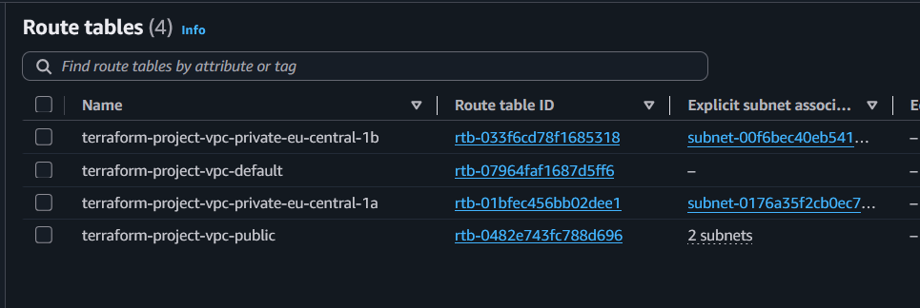

EC2
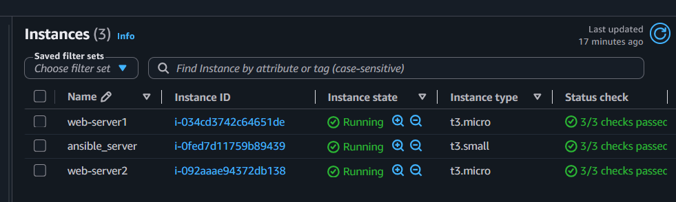

Jenkins CI/CD Pipeline – Build and Deploy
Overview
The deployment pipeline is divided into two independent Jenkins jobs:
- Build Job – Builds the application, generates the WAR file, and uploads it to the S3 artifact bucket.
- Deploy Job – Downloads the required WAR version from S3 and deploys it to the target environment using Ansible.
This separation allows the same build artifact to be deployed to multiple environments without rebuilding the application.

Jenkins – Build Application
Purpose
This job performs the following tasks:
- Checks out the application source code.
- Builds the application using Maven.
- Generates a versioned WAR file.
- Uploads the WAR file to the S3 artifact repository.

Jenkins URL: http://172.16.16.170:48080/job/Addressbook-Build/
Git Repo: https://github.com/gajrajparihar/addressbook/tree/main
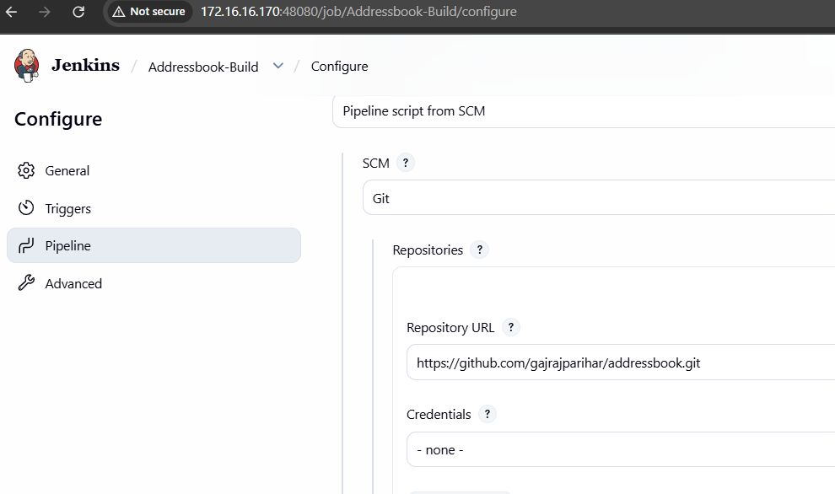
Build Process
- Checkout application repository.
- Configure JDK and Maven.
- Build using Maven.
Example:
mvn clean package
Upload generated WAR to S3.
location:
s3://gajraj-test/test/addressbook/
Generated artifact:
addressbook-2.1.war

Artifact Repository
S3 Bucket
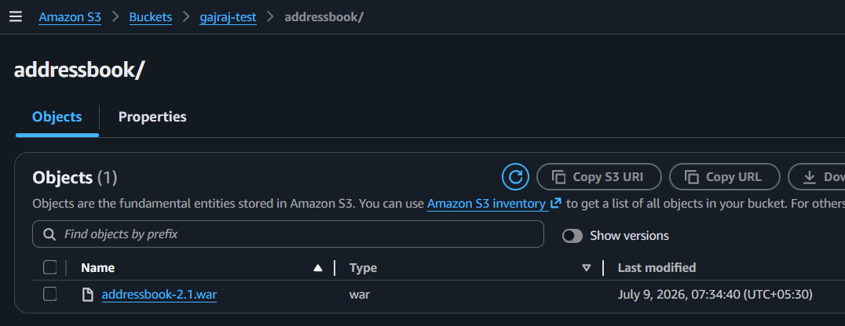
Jenkins – Deploy Application
Purpose
Deploys an existing WAR from S3 to the target server using Ansible.
No application build is performed during deployment.
Parameters
Parameter | Description | Example
APP_VERSION | Version to deploy | 2.1

Jenkins URL: https://operations.sw.technia.cloud:8443/view/OPs/job/Jenkins-Terraform-Deploy/
Github Repo: https://github.com/gajrajparihar/ansible-project.git
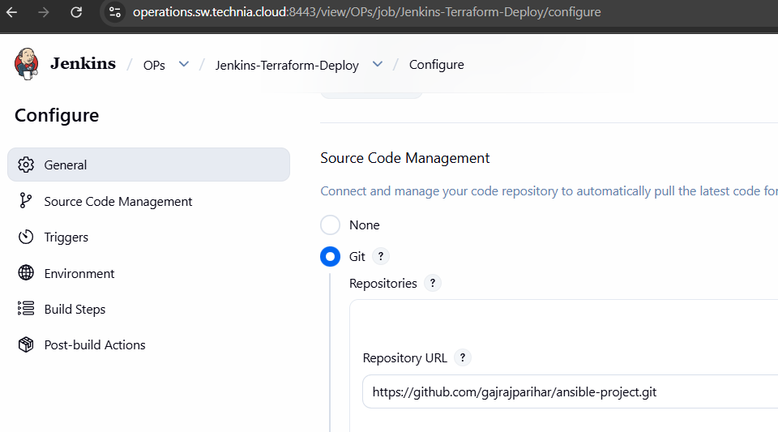

Deployment Process
- Checkout Ansible repository.
- Verify server connectivity.
- Override the default application version.
Jenkins task:
ansible-playbook -l app \
tomcat_install.yml \
deploy_war.yml \
tomcat_restart.yml \
-e "app_version=${APP_VERSION}"

- Download the requested WAR from S3.
- Copy WAR to the Tomcat webapps directory and restart Tomcat.
- Verify the application is running.
- Attached tomcat log

Outcome
Build Job
- JDK installed.
- Maven installed.
- AWS CLI configured.
Deploy Job
- Ansible installed.
- SSH access to target servers.
- AWS credentials with read access to the artifact bucket.
- Target server reachable from the Jenkins agent.
- Tomcat installed and managed as a systemd service.
- War file downloaded from S3 and deployed to tomcat
- Application is up and running

Application on server (3.120.158.154)
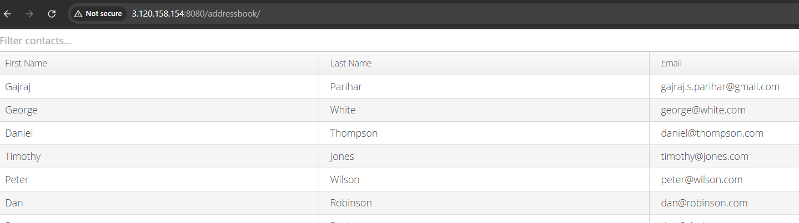

Application on Server (18.185.56.63)
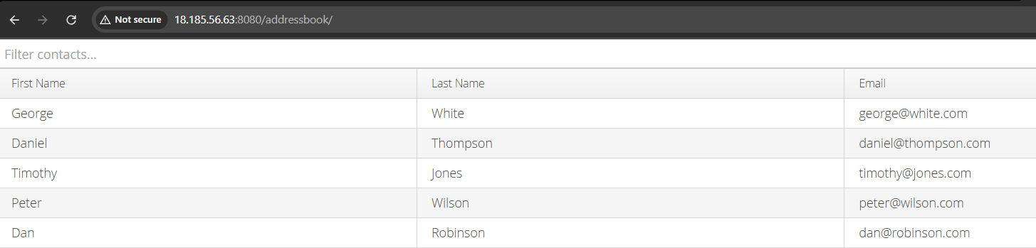

Deployment Architecture
Developer
│
▼
Jenkins Build Job
│
Maven Build (WAR)
│
▼
Amazon S3 Bucket
│
▼
Jenkins Deploy Job
│
Ansible
│
▼
EC2 (Stage / Prod)
│
Apache Tomcat
│
▼
Application Avaiable

Benefits
- Build once, deploy many times.
- Same artifact promoted across environments.
- Faster deployments.
- Complete artifact traceability.
- Easy rollback by deploying an earlier version.
- Separation of build and deployment responsibilities.
- Infrastructure managed independently from application code.

Environment Variables
Variable | Description
APP_VERSION | Version deployed by Ansible
This design enables independent application builds and deployments, ensuring reproducible releases and simplified promotion of artifacts across environments.

